**LETTINGS POLICY**

(Please read in conjunction with “Conditions of Hire” form SL1, which also forms part of our policy)

LARGE HALL

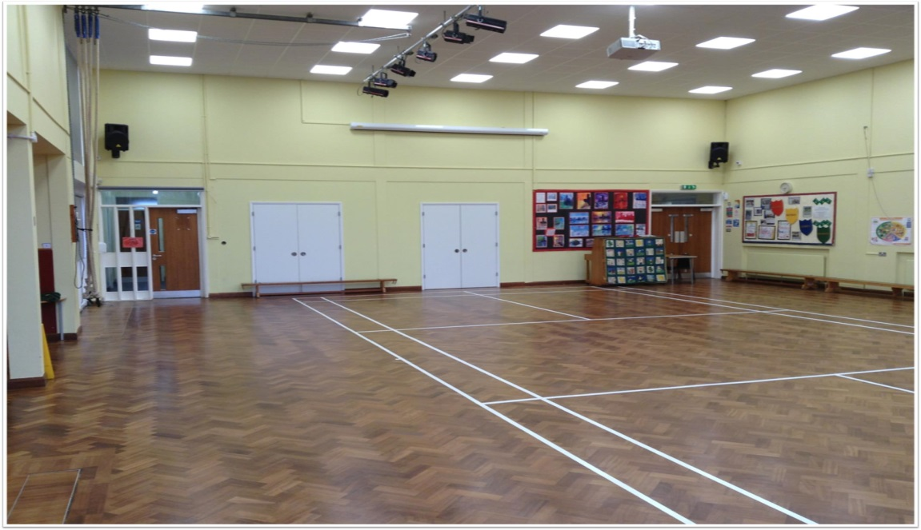

SMALL HALL

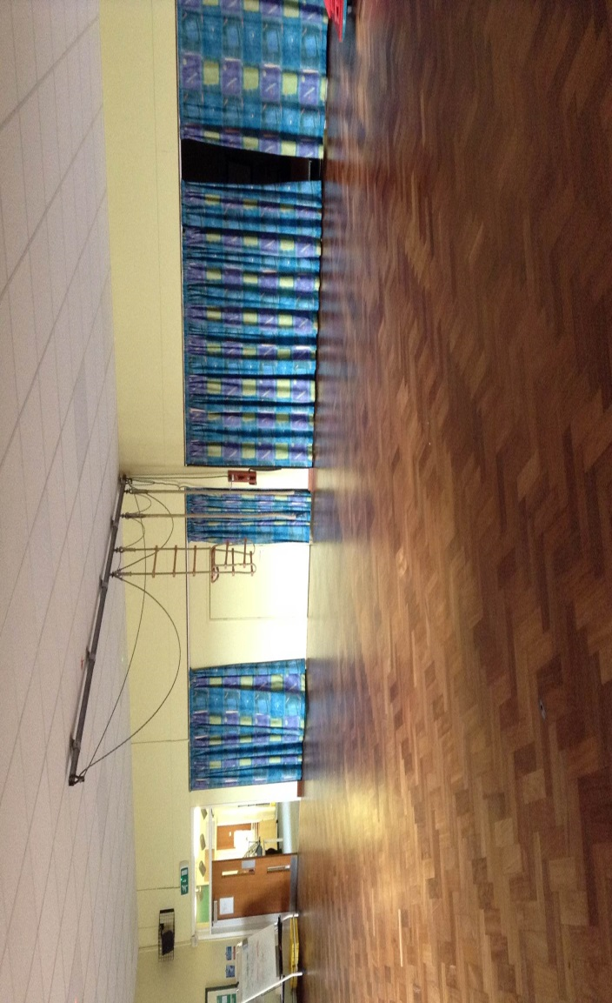

**CHARGES (from 01.04.2017)**

(reviewed annually)

|  |  |
| --- | --- |
| Fixed charge per session (payable per hall, per hire period).  Includes 1st hour hire | £40 |
| **PLUS** (per hour/part hour) |  |
| Large hall | £15 |
| Small hall | £10 |

**Examples:-**

**1 hour in the large hall = £40**

**3 hours in the small hall = £60**

**Charges:**   Charges will be set out in the letting agreement between the school and hirer, the governing body will periodically review these charges, giving the hirer at least one half terms notice of any changes in fees or conditions of hire.

**Types of Lettings** -   Single lettings are those where an individual or organisation wishes to hire facilities on a one off basis, these lettings should still be subject to a formal lettings agreement and follow the same principles as a continuous letting.  Continuous lettings are those that run for a number of weeks or terms.

**Letting Agreement** - All lettings (even those where no charge is made) must be subject to a letting agreement, this will detail the terms of the letting and must be signed by both the school and the hirer. A letting should only be confirmed as accepted when a signed letting agreement is in place.  Any amendments to an agreement will require a new agreement form to be signed.

**Safeguarding.** - London Meed CP School is committed to safeguarding and promoting the welfare of children and expects all staff, volunteers and hirers to share this commitment. All hirers are requested, to complete and return appendix 1.

**Prevent Duty (radicalisation). -** The governing body will not let the school premises to organisations whose purpose is, amongst other things, to encourage racial discrimination and/or disharmony between persons of different religious or racial groups, or are otherwise involved in activities prejudicial to good race relations.

**Equal Opportunities** – School premises must not be let to any individual, group or organisation that does not subscribe and adhere to the schools statement on equal opportunities.

**Political Use** – School premises must not be let for political use, the only exception to this is as a polling station.

**Legal Use** - It is the responsibility of the person letting the premises (hirer) to ensure the premises will not be used for any purpose which may be deemed contrary to English law.  The school is a community building and the hirer will be held responsible for noise levels and guest behaviour which must not offend other users or local residents.

**Named Individual** – The hirer must provide the school with a named individual who the school can contact in the case of an emergency, this person must be on the premises for the duration of the letting.

**Safety –** During the period of the letting the hirer’s named individual will be responsible for following the conditions of booking (see “Conditions of hire”), and ensuring the safety of those using the premises.  The named individual will have the responsibility for complying with School Health & Safety Policy (copy should be made available on request to hirer) and any other instructions or guidance provided by the Head Teacher.

The school will provide the hirer with the name and phone number of school contacts in the case of an emergency.  A member of school staff will be responsible for showing the hirer’s named individual how to raise the alarm in an emergency, this will include location of appropriate fire exits, fire extinguishers, evacuation and fire collation points.  The school will also have responsibility for organising periodic fire drills.  It will be the named individual’s responsibility to keep a register of those attending the event/activity, ensure fire exits are not obstructed and that school security is not compromised.

No equipment can be brought on to the site without the prior approval of the head teacher, electrical equipment will also require a PAT testing certificate.  Alcohol, smoking, drugs & gambling are not appropriate activities on school premises.

Access to the school car park should be limited especially if young children are on site.

**Risk Assessments** –Where appropriate the hirer will be responsible for undertaking their own risk assessments for specific activities and providing their own first aider.  The school’s cooking facilities must not be used unless prior permission has been obtained.

**Insurance** – neither CYPS nor the school provide hirers with public liability insurance against personal injury, accident, loss or damage to property.  The hirer must provide evidence to the head teacher that they have adequate insurance cover in place before a letting can be agreed.  It is recommended that Public Liability insurance to the value of £2million is in place for low risk activities (e.g. adult education classes) and £5million for high risk activities (e.g. gymnastic class).

**Damage:**  The hirer will be responsible for the cost of any damage to school premises or equipment, school staff have free access to all parts of the school site during lettings to check hirers are acting in a responsible manner.

**Cleaning/Security:**  Any costs for cleaning or providing building security will be detailed in the letting agreement, where such costs are not identified, responsibility for cleaning and security will be the responsibility of the hirer.  School site staff will be responsible for opening and closing the school unless alternative arrangements have been agreed with the Head Teacher**.**

**Cancellation & Complaints:**   The school (via the head teacher or other appointed representative) has the right to cancel any letting, reasonable notice of cancellation will be given by the school unless the hirer is in breach of the letting agreement, upon which cancellation will take immediate effect.

Where the hirer has a complaint the schools standard complaints policy and process will apply, if the school has a complaint about the hirer, in the first instance the Premises Officer will raise this with the named person, if the complaint is not resolved it will be escalated to the governing body to decide on the appropriate action for the school to take.

**Declaration of Interest:**   Any members of school staff or governors having connection with a letting must formally declare this, declarations should be formally minuted at the appropriate meeting.

The school should not be let at a financial loss, whilst governing bodies can cross subsidise lettings by charging different amounts for different purposes, delegated budgets must not be used to subsidise non-school activities.

The Governing body in conjunction with the school Head Teacher will decide on the process for agreeing if and what school facilities will be let to a 3rd party and on what terms. In some instances the school will need to obtain formal approval for use of the site from the Children & Young People’s Service (CYPS) , this will depend on the nature of and risks involved in the letting.

**Other documents you should also refer to/make available to hirer:**

* Conditions of hire
* Lettings Agreement  (school & hirer)
* Health & Safety Policy, School Complaints Policy, Equal Opportunities Policy (available to hirer on request)
* Charges Policy/Rates
* Relevant Risk Assessments & Emergency Procedures (school & hirer)
* Copy of Public Liability Insurance (from hirer)

**********NEXT REVIEW DATE OCTOBER 2017**********