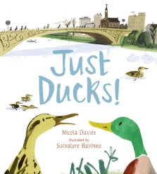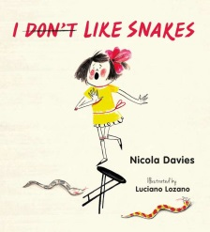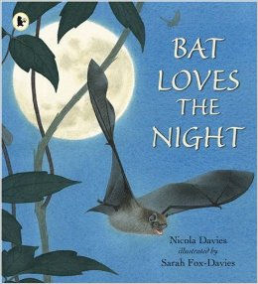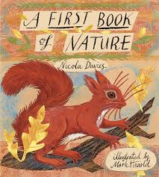
Just Ducks I don't like snakes Bat loves the night A first book of Nature
Nicola Davies
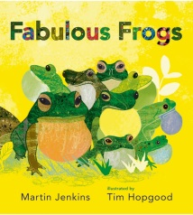
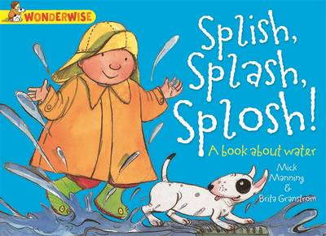

Fabulous Frogs Splish Splash Splosh
Martin Jenkins
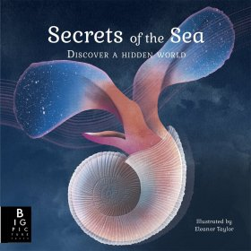

Secrets of the Sea
Kate Baker

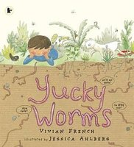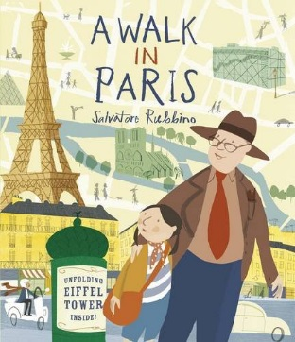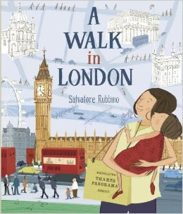
Yucky Worms A Walk in Paris A Walk in London
Vivian French Salvatore Rubbino

