**Lost in Time!**

**Please do not let the secrets out the bag and hold back from telling your child what**

**stories and activities we will be doing together!**

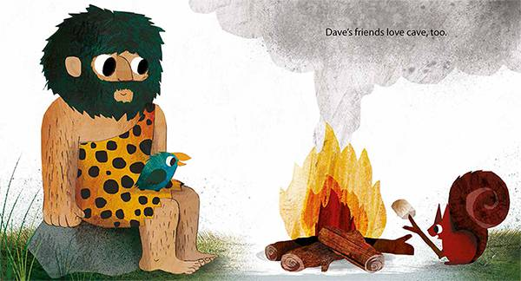

**Weeks 3 : School of Rock!**

We will be making performing some cavemen dances, making music to accompany these and doing drawings which represent how the music makes us feel.

**Weeks 2: Ug-a Lug!**

We will be focussing on cave art as well as introducing how to make safe use of our Forest School. Looking at fires safety and our Forest School rules.

**Weeks 1: Dave’s Cave!**

We will be looking at the fiction book “Dave’s Cave” by Frann Preston-Gannon and ‘Stone Age Boy!” by Satoshi Kitamura. We will look at the differences between the characters’ lives in the past and our present day lives.

**Week 4: Stone Girl Bone Girl!**

We will be presenting what we have found out about the Stone Age in a variety of ways, such as video, information posters and a Class book.

**Week 5: Spring has Sprung!**

We will be looking at lifecycles and changes over time. We will be looking at real life examples of these and doing some planting in our outdoor areas.

**Week 6: Eggstravaganza!**

We will be looking at Easter traditions around the world and inviting you to join us for our **FABULOUS FINISH on Tuesday 6th April at 2pm in the Small Hall** followed by a Book Look in our classrooms.