1. 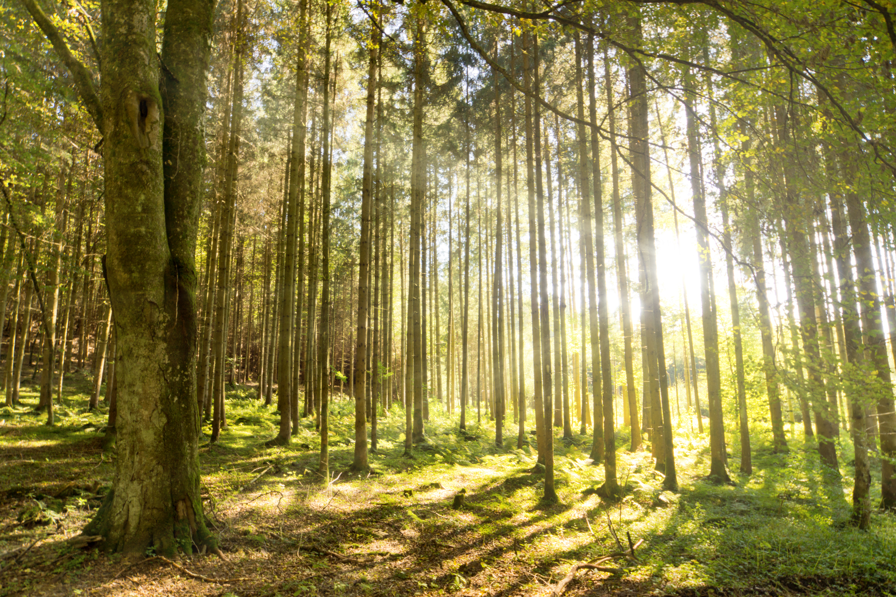

**Stunning Start**

Children discover a woodland animal in the classroom who is lost and needs our help to learn about the woods.

**Computing**

Objectives: To use technology to create, organise, store and retrieve digital content.

**PSHCE:**

Objectives: To focus on team-work and developing working relationships in the new class. Using fairy tale characters to explore empathy.

**Home Learning**

Children will be given a selection of home learning activities to complete in their home learning book. Books are to be returned each Wednesday.

**Maths**

Objectives: to know the value of each digit in 2 digit and 3 digit numbers, to partition numbers, to count in multiples of 2,3, 5 and 10. To know number bonds to 10, 20 and 100 and to add and subtract using concrete apparatus.

To name and identify the properties of 2D and 3D shapes, recognise lines of symmetry and right angles. To estimate length and mass using standard units.

**Music**

Objectives: To compose our own woodland soundtrack to tell a fairy tale through music. Guest visit from Ollie Heath.

**RE**

Topics: We will be investigating Christian festivals and Harvest.

**Art/DT**

Objectives: To used mixed media to create woodland inspired pictures. To capture the elements of the forest using different materials and techniques. To look at the work of Andy Goldsworthy.

**Year 2**

***Into the Woods***

Autumn 2016

**English – Fiction**

Objectives: To write alternative versions of fairy tales set in the woods.

Narrative writing based on ‘Little Red’.

To use speech bubbles for character dialogue.

To write from a different point of view.

.

**English – Non-fiction**

Objectives: To research using non-fiction books and use topic-based vocabulary to create a factsheet. To describe a woodland animal based on their research.

**Geography**

Objectives: using maps to recognise woodland areas and identify symbols.

To compare and contrast urban and rural areas.

**Science – Living things and their habitats**

Objectives: To compare differences between living, dead and non-living things. To explore and describe habitats and simple food- chains. To explore the requirements of plants.

**English – Poetry**

Objectives: To produce a sensory poem about the woods.

**PE**

Objectives: Dance, choreographing woodland inspired dance.

Games-To practice and refine a variety of ball skills.