1. 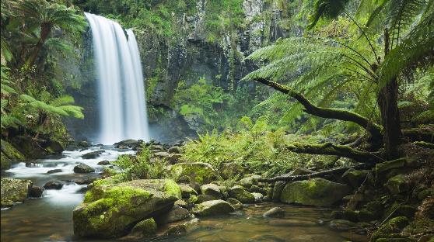

**PE**

Objectives: Athletics – To practise and refine techniques for sprinting, throwing and jumping.

Cricket – To acquire and develop appropriate skills.

**Literacy – Poetry**

Objectives: To capture the mood of the rainforest through poetry.

**Science – Plants / Habitat**

Objectives: To understand how plants grow in the different layers of the rainforest. To label parts of a plant.

To investigate rainforest animals and their habitats.

**French**

Objectives: Learning key vocabulary related to the weather, nature and the rainforest.

**Geography**

Objectives: To identify key geographical features of Brazil. To know where the world’s rainforests are positioned. To understand the effect of deforestation. To compare Rio with our local area.

**Literacy – Fiction**

Objectives: To write diary entries and narratives using paragraphs / conjunctions / word classes / sentence structures / clauses / pronouns / correct speech punctuation

**Art/DT**

Objectives: To use a range of mixed media to create artwork linked to the rainforest. To learn about the life and style of the artist Henri Rousseau.

**RE**

Topics: What is worship?

**Year 4**

***Explore Brazil***

**Music**

Objectives: To create the sounds of the rainforest. To compose our own Brazilian samba beats for the end of term festival.

**Computing**

Objectives: To create QR codes to use in topic books.

To capture shapes, colours, textures and detail in photographs.

To crop and edit photographs.

**PSHCE**

What will happen if the rainforest continues to be destroyed? How could we raise awareness?

PPP

**Home Learning**

Home Learning will be given out on Fridays and should be returned by the following

Wednesday.

**Maths**

Objectives: To continue to learn multiplication facts, explore the properties of shapes, investigate lines of symmetry, compare and classify angles, plot co-ordinates, collect and display data using a variety of graphs and charts.

**Literacy – Non-fiction**

Objectives: To research and record facts about the rainforest and its inhabitants.

To write a biography about Steve Backshall.

To compare and contrast the lives of people from different areas of Brazil.

**Stunning Start**

Children arrive into the classroom, where rainforest sounds will be playing. A letter has arrived from Steve Backshall, asking us to help him research the rainforest.