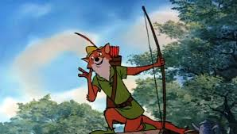

**Year 3**

Forest Friend or Foe

**R.E**

Signs and symbols Christianity

Into the Light - Hinduism

**Music**

World Music

Rhythm

Pitch

Using a variety of instruments.

**English**

Learn to use inverted commas

Use paragraphs.

Proof-read for errors in punctuation

Edit writing by adding or changing vocabulary

To learn how to create settings

Write free verse and diamante poems.

**Geography**

Identify the countries that make up the UK.

Identify major cities and towns in the UK.

Identify symbols for map reading.

**Guided Reading**

Infer characters’ feelings

Summarise texts

Make and justify predictions

Comment on the writers’ choice of vocabulary

Read and prepare playscripts and poems.

Retrieve information from non-fiction books

**Maths**

Place value – ones, tens and hundreds

Ordering and comparing numbers up to 1000.

Solving missing number problems

Add and subtracting 1, 10 and 100 mentally.

Adding and subtracting fractions

Properties of 2D and 3D shapes

Learning multiplication and division facts

**Science**

Plants and seeds

Habitats

**PE.**

Invasion games – football, netball and tag-rugby

Developing balance, stretching and landing, in gymnastics.

**Art**

Learning from famous artists such as Klimt

Using a range of mediums

Developing sketching and shading techniques

Learning about perspective

**French**

Read and write numbers to 20

Days and months

Greetings – Bonjour! Ca va?